# C# Web Basics Exam – 16 Feb 2020

# Shared Trip

Exam problems for the [C# Web Basics course @ SoftUni](https://softuni.bg/courses/csharp-web-basics). Submit your solutions in the **SoftUni judge** system (delete all "**bin**"/"**obj**" folders).

**Shared Trip** is an online platform which is used to create and book trips from point to point.

## Technological Requirements

* Use the **SIS**
* Use **Entity Framework Core – 3.1**

The Technological Requirements are **ABSOLUTE**. If you do not follow them, you will **NOT** be scored for other Requirements.

Now that you know the **Technological Requirements**, let us see what the **Functional Requirements** are.

## Database Requirements

The **Database** of **SharedTrip** needs to support **3 entities**:

### User

* Has an Id – a **string, Primary Key**
* Has a Username – a string with **min length** **5** and **max length 20** (**required**)
* Has an Email - a string (**required**)
* Has a Password – a string with **min length** **6** and **max length 20** - hashed in the database (**required**)
* Has **UserTrips** collection – a **UserTrip** type

### Trip

* Has an Id – a **string, Primary Key**
* Has a StartPoint – a string (**required**)
* Has a EndPoint – a string (**required**)
* Has a DepartureTime – a datetime (**required**) (use format: "**dd.MM.yyyy HH:mm**")
* Has a Seats – an integer with **min value 2** and **max value 6** (**required**)
* Has a Description – a string with **max length 80** (**required**)
* Has a ImagePath – a string
* Has **UserTrips** collection – a **UserTrip** type

### UserTrip

* Has UserId – a **string**
* Has User – a User object
* Has **TripId**– a **string**
* Has Trip – a Trip object

Implement the entities with the **correct datatypes** and their **relations**.

## Page Requirements

### Index Page (logged-out user)

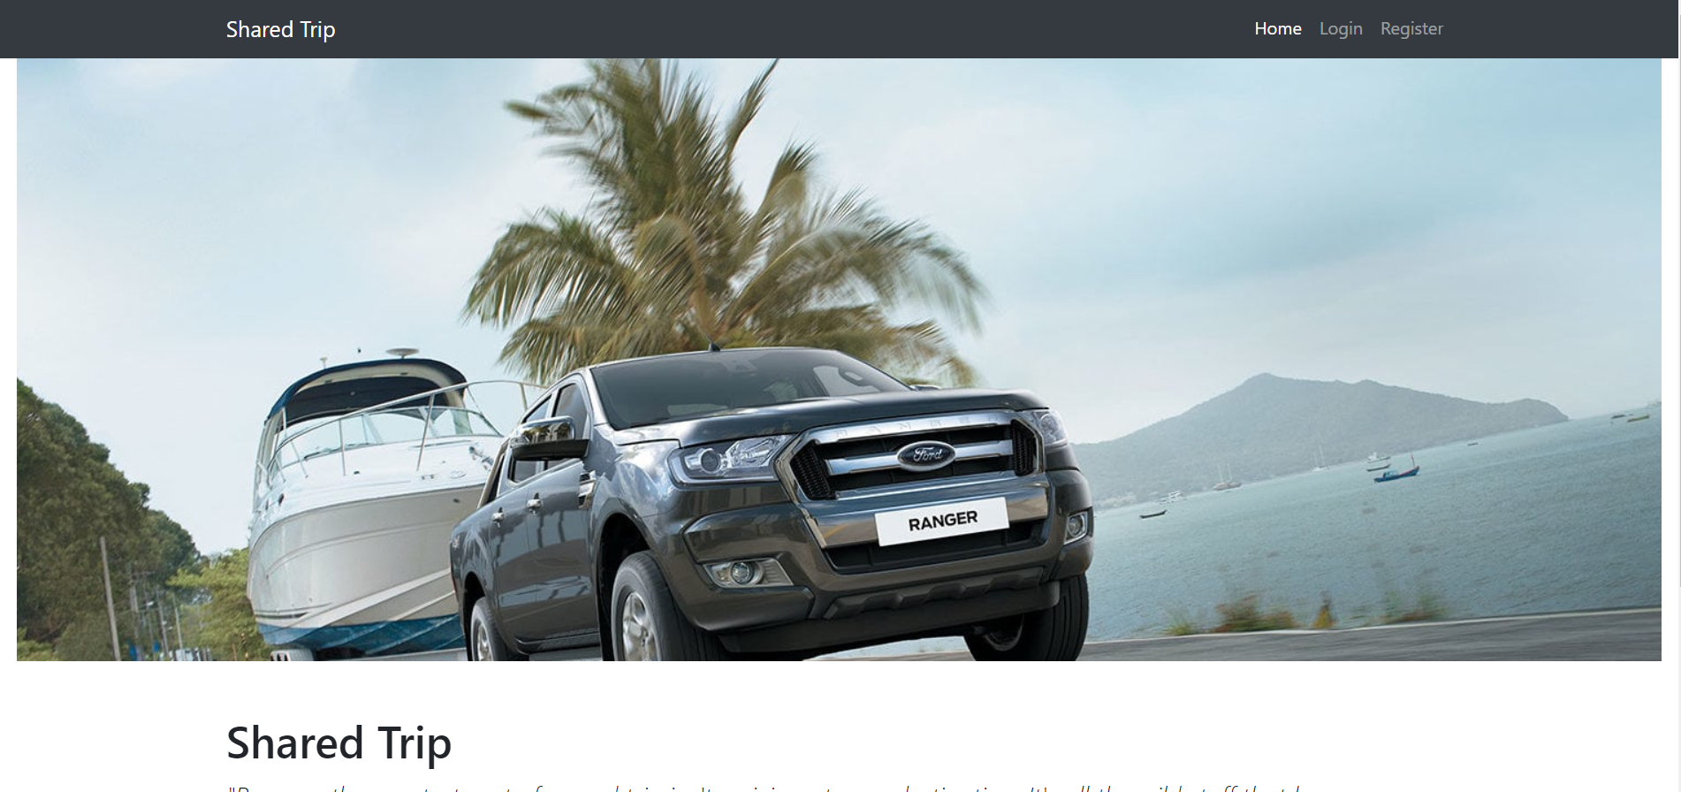

### Login Page (logged-out user)

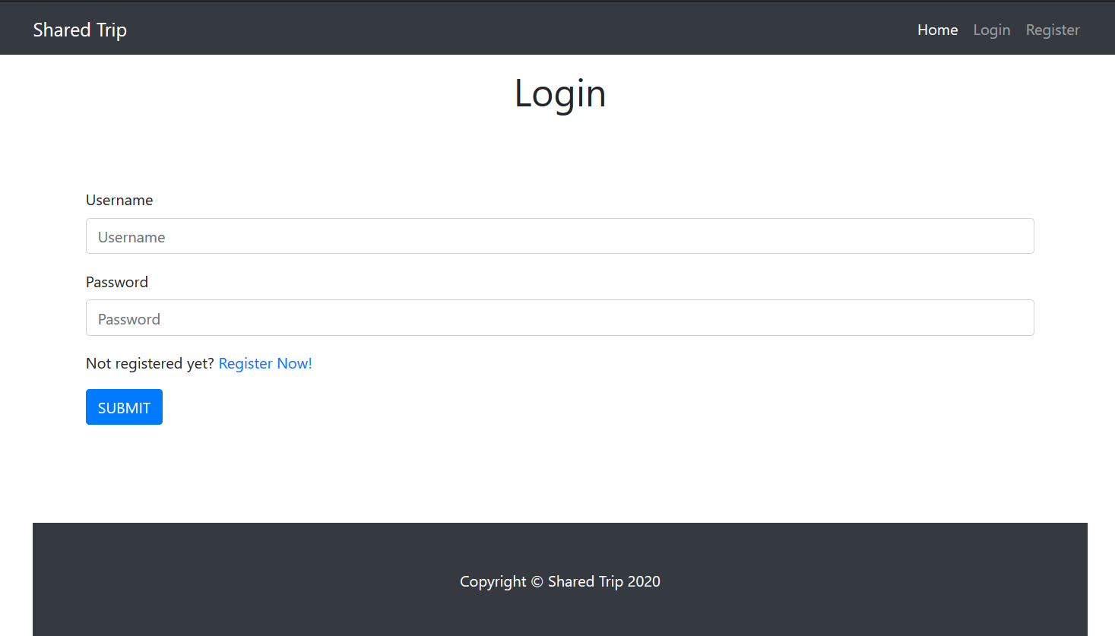

### Register Page (logged-out user)

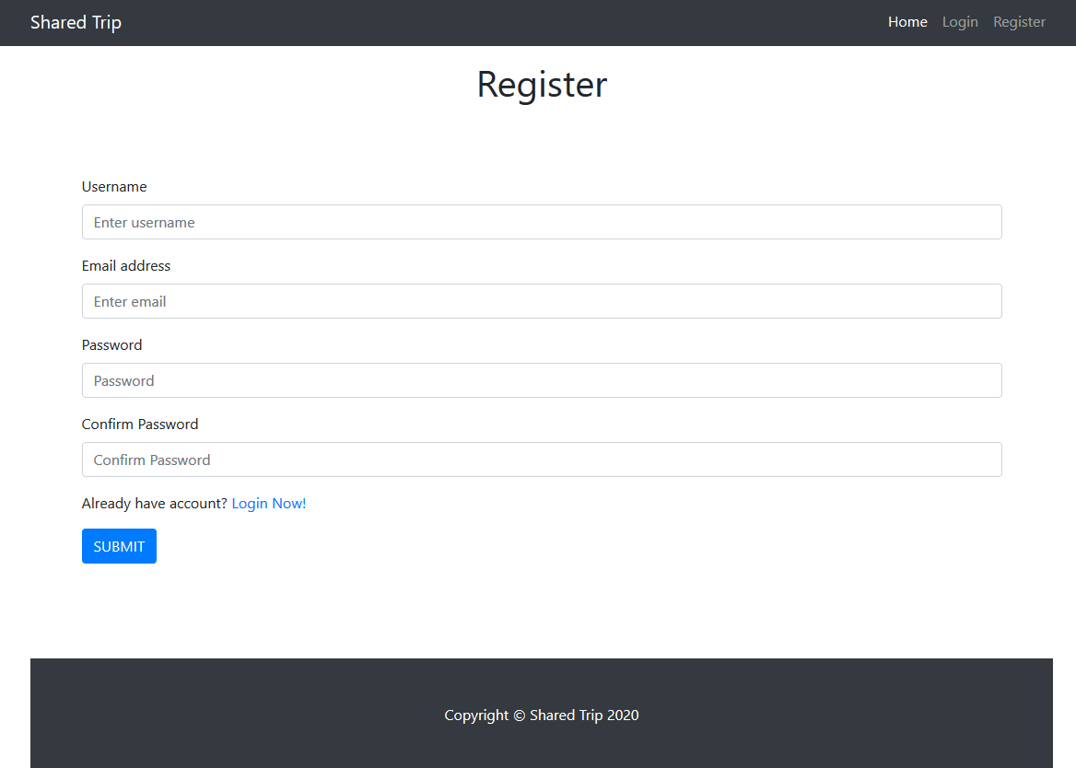

### /Trips/All (logged-in user)

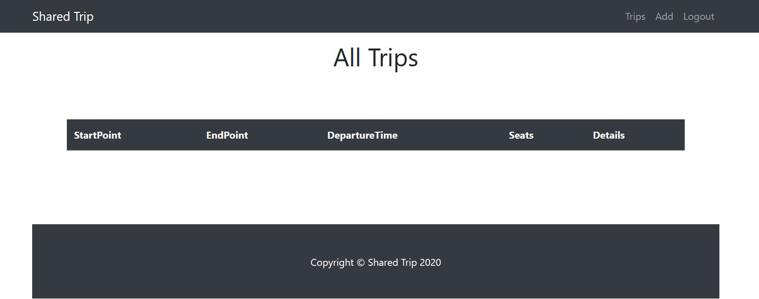

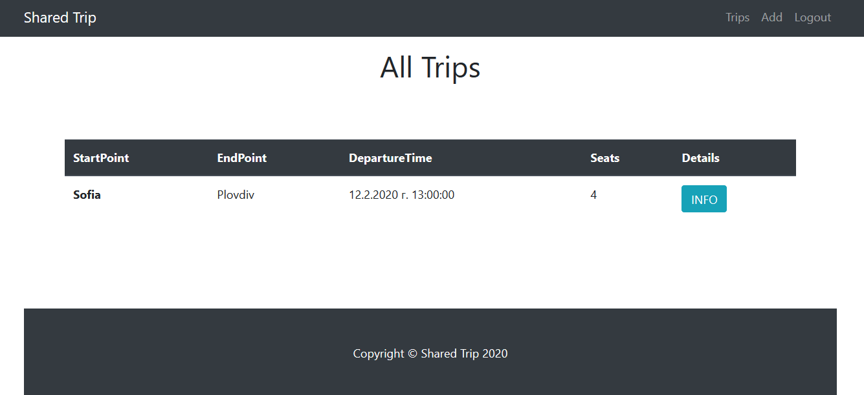

**NOTE**: If the user is logged in and he tries to go the home page, the application must redirect him to the **/Trips/All**

### /Trips/Add (logged-in user)

### /Trips/Details?tripId={tripId} (logged-in user)

### /Trips/AddUserToTrip?tripId={tripId} (logged-in user)

Adds the current user to the given trip. If everything is successful, the user must be redirect to the home page.

**NOTE**: The templates should look **EXACTLY** as shown above.

**NOTE**: The templates do **NOT** **require** **additional** **CSS** for you to write. Only **bootstrap** and the **given css** are enough.

## Functionality

The functionality of **SharedTrip** Platform is very simple.

### Users

Guests can Register, Login and view the Index Page.

Users can AddTrips and see Added Trips on the Home Page. From the Home Page they can also view Info about each one of those Trips and Join in a Trip.

### Trips

Trips can be Added by Users. All created Trips are visualized on the Home Page, each one in its own separate rectangular element.

Trips are visualized on the Home Page as a table with **StartPoint**, **EndPoint, DepartureTime, Seats (the currently free Seats), Details** and action **Info**.

Trips are visualized on the Home Page with button – [**Info**].

* The [**Info**] button leads to the Details Page of the trip

Trips have Details Page, where the information about them is displayed. At the bottom there is one button, which is Join. Upon pressing it, the User joins the Trip. A User can join the Trip just once! You should display the currently free seats.

### Redirections

* Upon successful Registration of a User, you should be redirected to the Login Page.
* Upon successful Login of a User, you should be redirected to the /Trips/All.
* Upon successful Creation of a Trip, you should be redirected to the /Trips/All.
* Upon successful Adding user to a trip, should be redirected to the /Trips/All.
* If any of the **validations** in the POST forms **don’t pass**, **redirect** to the **same page** (**reload/refresh** it).
* If a User tries to join a Trip more than once, they should be redirected to the **details page** of the given Trip.

## Security

The Security section mainly describes access requirements. Configurations about which users can access specific functionalities and pages:

* Guest (not logged in) users can access Index page.
* Guest (not logged in) users can access Login page.
* Guest (not logged in) users can access Register page.
* Users (logged in) cannot access Guest pages.
* Users (logged in) can access Trip Add page and functionality.
* Users (logged in) can access Trip Details page.
* Users (logged in) can access Trips All page and functionality.
* Users (logged in) can access Logout functionality.

## Code Quality

Make sure you provide the best architecture possible. Structure your code into different classes, follow the principles of high-quality code (**SOLID**). You will be scored for the Code Quality and Architecture of your project.

## Scoring

### Database Requirements – 10 points.

### Template Requirements – 10 points.

### Functionality – 50 points.

### Security – 10 points.

### Code Quality – 10 points.

### Data Validation – 10 points.